Email is the most effective
and efficient means of having substantive communication with your instructors. However, email is not without its risks: emails can get lost, they can be misunderstood, it is impossible to know the true identity of the sender, it could be spam, or it could contain a computer virus or other malicious code. People have lost their jobs, had their reputations wrecked, and other catastrophes occur, simply by not using email safely and appropriately.

The purpose of this document is to help you use email safely and appropriately.

The purpose of this document is to explain how you are to format and compose emails to your instructors. If you follow these rules; then you will be using email with more safety and will also likely have fewer problems: at least as far as email is concerned.

The typical email is composed of the following:

- The recipient
- The sender
- The subject line
- The body of the message
- Attachments
- The records that document that the message has been sent: save your sent email.

1. Recipient
Make sure you know your instructors correct email addresses. These are listed on the course outline and on the course website (if one is being used). Sending the wrong message to the wrong person has wrecked the careers of many people. It is rarely acceptable.

2. Sender
Most email clients (your email software: Outlook for example) will allow you to specify a name that is displayed as the email sender. Please take advantage of this feature. Many of us have funny email handles or addresses: this is fine for friends and casual email but not for our purposes. Emails sent to your instructors are professional emails and you must identify yourself clearly. Add a signature file to your email client to make it clear to your reader who you are.

3. Subject Line
This is probably the most important and most frequently overlooked part of an email. A well written subject line makes it easy to find, read, respond to, and store an email. In order to ensure that your instructor will see your email you must adhere to the following instructions:

- Start the subject line with a square bracket: [
- Put in your course number e.g. HTTP 5102.
- Put in your name.
- Put in the reason for your email
- Close the subject line with the right square bracket: ]

So a properly formatted subject will look like this:

[HTTP 5102: Bernie Monette: timesheet assignment]
or
[HTTP 5206: Joan Doe: questions about due dates]
in general
[Course number: your name: reason for the email]

Get the picture? Any questions?

Your instructors get a lot of email and the point of formatting the subject line is to make sure they can see your emails and respond. There is a high probability that your instructor will not see your email unless you follow these instructions. If it is an assignment, then it is likely that it will be marked late or not marked at all.

4. Body of the Message
You are expected to communicate in a clear and professional manner with your instructor. We expect proper spelling, good grammar, and a clear message. Remember to be polite and do not write anything you would be embarrassed to read elsewhere. Check your spelling: you risk confusing your reader if you have confusing short forms or odd spelling. Moreover, you are also expected to clearly identify yourself in the email. The easiest way to do this is to add a signature file through your email client (you may have read that before…)

5. Attachments
You will be expected to submit some assignments by email. Please make sure you know how to do attach documents and files to emails. If you fail to properly attach an assignment to an email then that assignment will be considered late, and subject to the late penalty, if you have not corrected the situation prior to the deadline.

6. Save your sent email
Everything you do online is, or may be, recorded. Here you can take advantage of this and save your emails. These are now a handy record of what you have said and what they have said. Having a copy of your email also gives you a chance to prove that they email was sent. Emails go missing all the time and if that email has your assignment attacked how will you prove that you sent the assignment on time? If your email goes missing then you will be asked to forward your save email as proof that you submitted the assignment on time. If you are unable to do this then your assignment will graded as late and penalized accordingly.

Following these rules is a means of using email safely and wisely. It is also a means of protecting yourself from the mindless criticism of servers and email software that may erase your work. Marks may be deducted for not following these rules if that is what it takes to get your attention.

Here is an intriguing email I received yesterday:

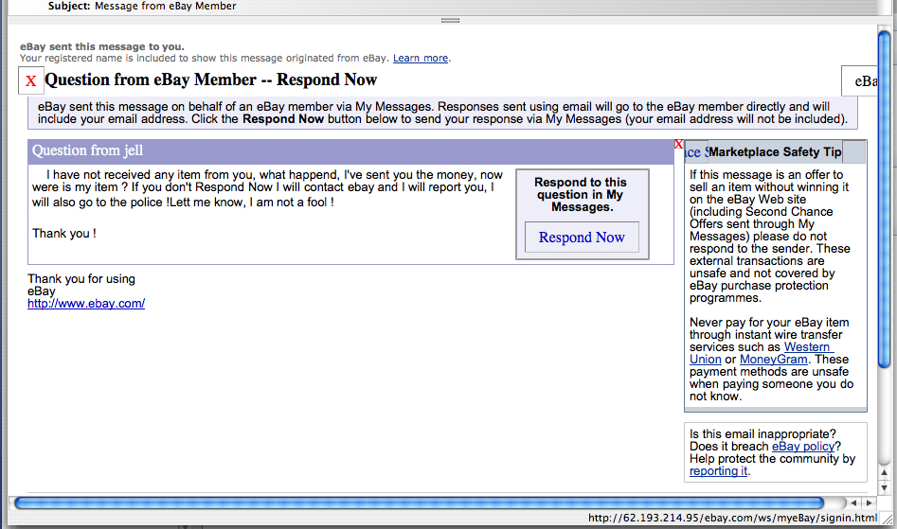
It can be difficult to stay on top of these things: but unless you want your bank account vacuumed you have to.

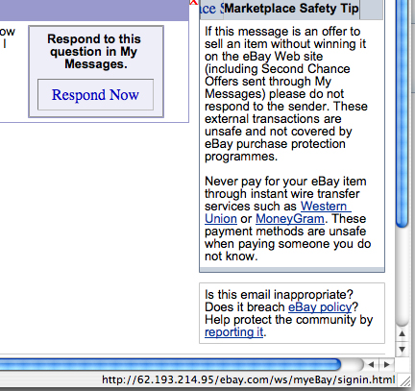

Here is a tip to understanding this kind of scam: the url shown here is where you would go if you clicked the “Respond Now” link. This is NOT an ebay address but has been designed to look like one.

A url reads in the following way:

Protocol – domain – folders – file

https://humber.ca/images/logo.gif - this would be the url for an image on the Humber domain.

http://62.193.214.95/ebay.com/ws/myeBay/sigin.html is very clever. The use of the words “ebay.com” mimics the domain. But it is not the domain – it is a folder called “ebay.com” – the true domain (the spamming, evil, phishing domain) is the i.p. address 62.193.214.95. The “ws/myeBay” are the subsequent folders holding “signin.html”. This is, you can imagine, a false login form (that probably looks authentic) to steal your username and password.

You will send me an email following these rules by Friday January 14th, 2022 at noon.

